Step by step guide for App
Replace the previous image with Previous one:
Hello, to clarify what we want done with the body is
1. The first picture is what’s shown when first opening the app.
2. When users taps on of the labels let’s say bicep then we have the animation of what’s already designed so bicep is highlighted as seen in the second image. We have made how the animations are supposed to look like
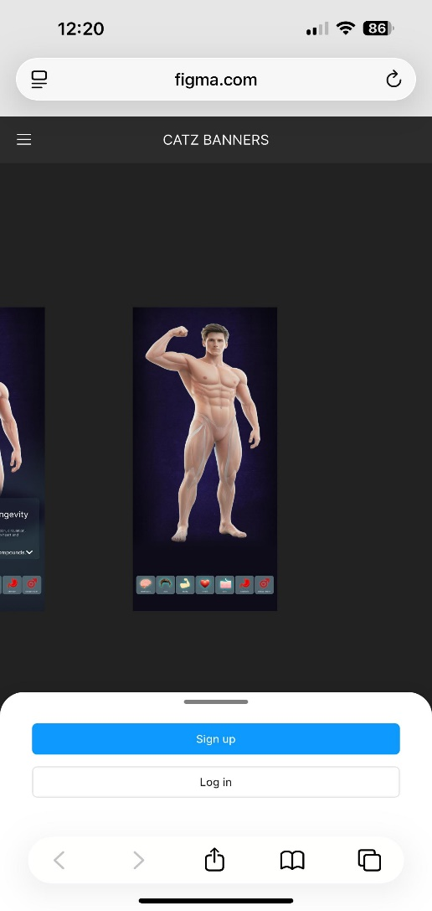
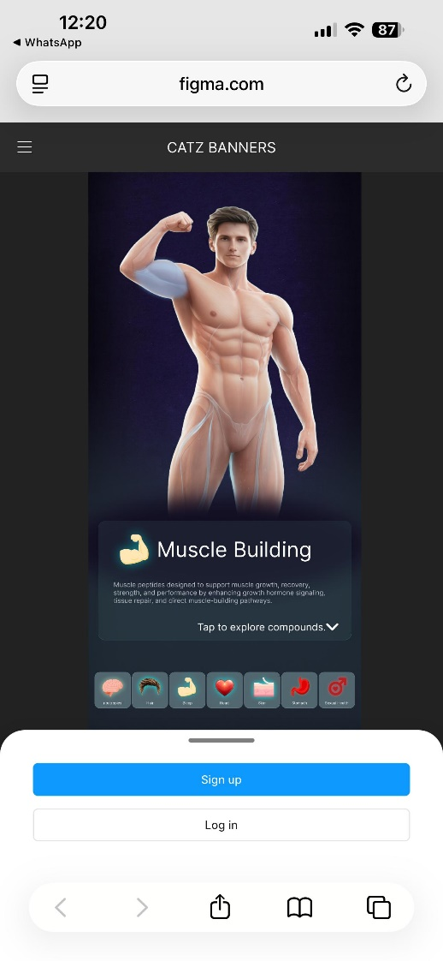

Example 2:
Another example to clear confusion.
Tapping on the heart from the fist image should lead to the second

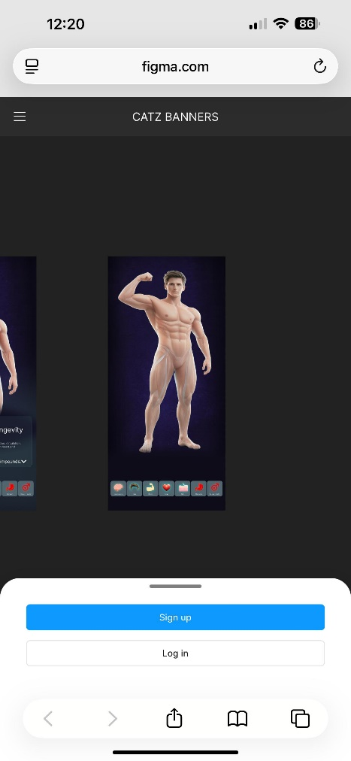
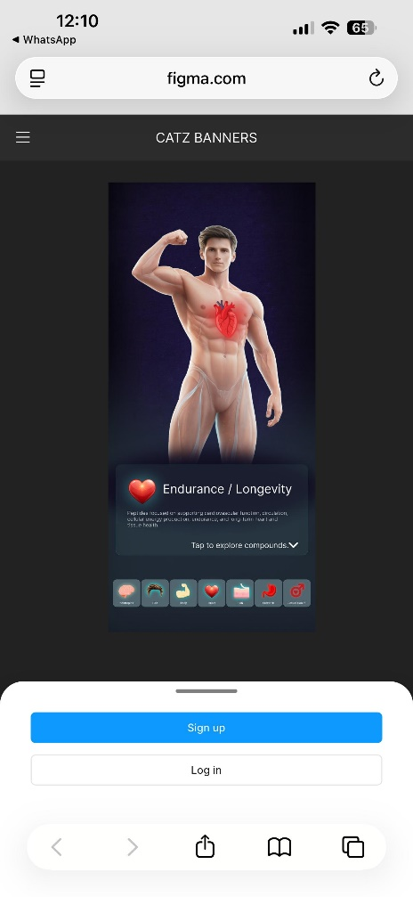

Point 2:
Another point animation should be smooth meaning only thing at once should show up users can have both the bicep and the heart show up at the same it switches. Another point if users say tapped on the heart label earlier then tapped on the heart label again the body goes back to being blank. Final point the body is no longer interactive it’s just “the tap to explore compounds” is and the labels those are the only interactive parts on the body page.

Point 3:
When people open the app there should be
1. Age confirmed 21 check box.
2. medical disclaimers 3.
Terms of service.
4. we see the beaker dancing screen.
5. sign with the new sign features we discussed.
6. The body with labels and blank.
7. the labels pop a little not the organs to show users it’s tappable.
8. tap on the fat loss label stomach appears as designed.
9. Tap on view compounds goes to page we already built with peptides and saving them for further research.
Now this is temporary for first time users only. 2nd time users once opening the app again the see the dancing beaker then tapping that leads to the body. Not straight to the body.
Point 4:
Sign up options
With Google
With apple
With email
And that's complete the project

